**Kol Simcha Torah Gazette**

**For Sukkos-Simchas Torah 5785**

Volume 9 Issue 4 (Whole #418) 15-23 Tishrei 5785/ October 17-25, 2024

**Printed L’illuy nishmas Nechama bas R’ Noach, a”h**

For a free subscription, please forward your request to [***keren18@juno.com***](mailto:keren18@juno.com)

***Past emails can be found on the website ShabbosStories.com under Brooklyn Torah Gazette***

**Hag HaSukkot:**

**Teshuva Me’Ahava**

**By Rabbi Eli Mansour**

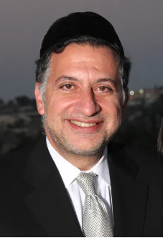

The Torah (Vayikra 23: 33-44) commands us to observe the Festival of Sukkot. However, the structure of the commandment is somewhat curious. It begins by describing the beginning and end of the Festival, and how one should not work on the first and eighth days. Afterwards, the Torah returns to the first day and describes other aspects of the Festival.

How are we to understand the order of these verses? Why does the Torah divide the commandment to observe the Festival of Sukkot in this manner? The Seforno explains that the Torah describes what all the Festivals have in common, i.e., not doing work and the korbanot, and then describes the uniqueness of the day, i.e., the festival on the eighth day, the arba minim and the sukka.

**The Connection Between the Bulls**

**Offered and the Seventy Nations**

The Torah returns to the topic of the korbanot in Parshat Pinhas. In this parasha, the Torah focuses on the various korbanot offered on each Festival. Regarding Sukkot, the Torah teaches that on the first day thirteen bulls are brought, and twelve on the second day, until the seventh day upon which seven are brought-- seventy bulls in total. The rabbis teach us that these seventy bulls correspond to the seventy nations. The Jewish people pray for the welfare of the nations of the world on Sukkot.

In addition to the seventy bulls, fourteen sheep (kevasim) are offered each day, totaling ninety-eight during the seven days of Sukkot. Some explain that these ninety-eight sheep correspond to the curses directed towards the Jewish people. The Kedushat Sion writes that if one counts the words of the curses of Parashat Ki Tova, there are 676 words. Interestingly, as it is clear that the curses are the result of our sins, it is not surprising that the total numerical value of the letters of the word avonot (sins), spelled out, equals 676.

What emerges, therefore, is a relationship between the ninety-eight sheep offered on Sukkot, and our avonot (sins). It appears that the sheep on Yom Kippur are meant to atone for the avonot (sins), for which there are 676 words of Divine curses. These ninety–eight sheep protect us from the curses of Parashat Ki Tavo.

However, we might ask, if Yom Kippur is understood as a day of atonement, why do the Jewish people need to be forgiven on Sukkot as well, days after Yom Kippur?

**Two Types of Teshuva**

The commentaries teach us that teshuva can atone for the sins of the past. The sins are no longer viewed as rebellious, purposeful acts, and therefore the person is not punished. This type of teshuva is known as teshuva me’yirah, repentance done from fear, and this is the teshuva of Yom Kippur. However, there is another type of teshuva – teshuva me’ahava – teshuva done from love of G-d.

The rabbis teach us that when one repents due to one’s love of G-d, his sins are then viewed as good deeds. On Sukkot, the Festival of simha, we perform teshuva me’ahava. On those days, the ninety-eight sheep, which correspond to the curses of Parshat Ki Tavo, represent the sins (avonot) which are atoned for on Sukkot due to our teshuva of ahava, reflected by the korbanot of Sukkot. It is this happiness, and atonement, which explains the unique experience of Sukkot.

*Reprinted from the September 20, 2024 email of Daily Halacha.*

**The Greatness of the**

**Simchat Beit Hasho’eiva**

**From the Teachings of the Lubavitcher Rebbe**

**Rabbi Menachem Mendel Schneerson, Zt”l**

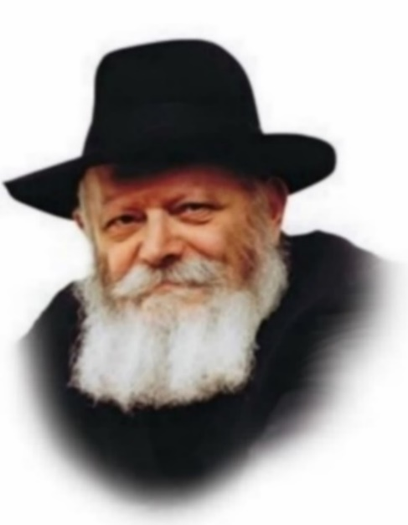

In the times of the Holy Temple, the rejoicing of Sukkot reached its culmination in the water-drawing celebration known as Simchat Beit Hasho'eiva. On the second night of the holiday, spring water was poured upon the altar, as the prophet Isaiah says, "You shall draw water with joy from the springs of salvation."

Our Sages declared: "Whoever has not seen the rejoicing of the water-drawing has never seen true joy." Conversely, the opposite is also true: Anyone who witnessed and participated in Simchat Beit Hasho'eiva merited to experience true joy.

Furthermore, as alluded to in the above statement of our Sages, by participating in the water-drawing festivities, a person merits that this happiness will continue throughout his lifetime.

"Rabbi Yehoshua ben Levi said: 'Why is it called Simchat Beit Hasho'eiva, the joy of the water-drawing? Because Ruach Hakodesh [Divine inspiration] was drawn from it. This teaches that Divine inspiration only rests on a person whose heart is glad.' "

As the Maggid of Mezeritch (Rabbi Dov Ber, the successor to the Baal Shem Tov) explained, everyone who participated in the water-drawing festivities derived this Divine inspiration. This included even young children and babies whose parents had brought them to the Holy Temple to witness the event.

This is an astounding fact. How can it be that even the tiniest babies experienced Ruach Hakodesh? Surely they were too young to understand what was being celebrated, not to mention the very concept of Divine inspiration.

The answer is that intellectual understanding or comprehension was not required. When Moses came down from Sinai with the Tablets of the Law, his face was radiant with a special light. Yet the Torah tells us that "Moses did not know that the skin of his face shone." Moses was unaware of this extraordinary phenomenon!

If a person of the stature of Moses could not perceive this marvel, how much more so is it possible for tiny babies to have merited Divine inspiration during the water-drawing celebration, yet not be aware of it!

The same principle applies to the "revelation of Elijah the Prophet." It sometimes happens that Elijah will reveal himself to a Jew, yet the person to whom he is revealed is unaware of it.

From this we learn how important it is for every Jew to participate in the Simchat Beit Hasho'eiva on Sukkot.

*Reprinted from the Succos 5761/2000 edition of L’Chaim. Adapted from Maayanei Hayeshua.*

**Rain, Rain Go Away**

**By Steve Hyatt**

As a child growing up in Waterford, Connecticut, my family went to shul for Rosh Hashana and Yom Kippur and celebrated Chanuka and Purim with childlike zeal. In fact, many people still feel that I was the best seven-year-old Mordechai they'd ever seen in the annual Ahaveth Chesed synagogue's Purim play!

But in all my years I had never seen, let alone set foot in, a sukka. So, one of the more extraordinary experiences of my adult life was helping build the Chabad Community Sukka in Wilmington, Delaware.

I can vividly remember building that sukka. About a week before the start of the holiday, Rabbi Vogel asked for volunteers to help erect the shul's community sukka. I had enjoyed a lot of firsts since discovering Chabad of Delaware so I figured, why not.

Later that day, six of us gathered at the Rabbi's home and began constructing the sukka. Despite the fact that our ancestors had been building these temporary structures for over 3300 years, this was the first time I had ever joined the construction crew. Together, our team hoisted large wooden panels into place, bolted them together and created a four-walled free standing temporary dwelling.

**The Fresh Branches that Help**

**Form the Roof of the Sukka**

Since I am 6'3" tall, I was placed on s'chach duty. What is s'chach you ask? Hey, I couldn't pronounce it either. Rabbi Vogel informed me that s'chach are the fresh branches that help form the roof of the sukka. I had the honor of placing the s'chach on the bamboo poles that served as the roof support structure.

It only took about twenty minutes to place the entire load of s'chach on the sukka roof but it has taken me four years to even come close to pronouncing the word properly. No matter how I try, I can't get the word out of my mouth!

After all the time and effort, we put into building the sukka I couldn't wait for the holiday of Sukkot to arrive. I could almost smell the Shabbat meal we were going to enjoy within the cozy confines of our temporary dwelling. There promised to be lots of the Rebbetzin's world-famous kugel and the best matzo ball soup this side of Jerusalem.

**The Rabbi and His Family Appeare Not**

**to Be Concerned by the Sound of Rain**

That Shabbat I arrived at the Vogel's, wearing my best Shabbat clothes, and proclaimed for all to hear that I was ready to eat in the sukka. After we said the evening prayers, everyone moved to the sukka and the Rabbi said the Kiddush blessing over the wine. Half- way through Kiddush I heard the distinctive sound of rain. I looked at the Rabbi, the Rebbetzin and the Vogel kids and no one appeared to pay the slightest bit of attention to the rain. I figured they were confident the s'chach would form an impenetrable barrier and keep us dry throughout the night's festivities.

Moments later, the Rabbi completed Kiddush and we all went to ritually wash our hands before saying the Hamotzi blessing over the challa. When we returned, a powerful storm was raging just outside the confines of our cozy temporary dwelling. Rabbi Vogel handed me a piece of challa and I said the blessing and took a bite. I had barely put the challa in my mouth when an enormous drop of water hit me right on the bridge of my nose. A few moments went by and more and more drops began to fall from the roof. I looked around the table and no one was paying any attention to the rivers of water freely falling from the "ceiling."

The Rebbetzin served the soup and suddenly a little piece of fresh s'chach plopped right down into the middle of my bowl. To my chagrin, the downpour in the sukka began to increase in intensity. My clothes were soaked, but worst of all my challa was a bloated mass of soggy mush! Holding the limp slice out to the Rabbi I asked if it might not be time to take the "party" inside where it was warm, dry and comfortable.

**“No One Ever Said a Mitzva Had to be Easy”**

Rabbi Vogel picked up a slice of waterlogged challa, and pointing it in my general direction said, "Shloma Yakov, no one ever said a mitzva had to be easy. For 3311 years your ancestors have been performing the mitzva of 'dwelling' in a sukka. In Alaska right now it's ten degrees below zero and 'the frozen chosen,' as Alaska's Chabad Rabbi Yosef Greenberg calls his congregation, are celebrating Shabbat in the sukka with joy and vigor.

“Take your mind off the rain and concentrate on the joy of fulfilling G-d's mitzva of eating in the sukka and honoring the memory of your ancestors who lived in dwellings just like these for forty years."

He waited a moment for his words to sink in and then added, "But... if the rain really bothers you, feel free to go inside."

**Inspired by the Five-Year Old Boy Sholom**

I was contemplating his words when another big, fat drop defiantly deposited itself on the tip of my nose, daring me to go in the house with the faint of heart. Seated next to me was the Rabbi's youngest son Sholom. He was oblivious to the rain as he happily played with his soggy challa and kugel. Finally, I came to the conclusion that if a five-year-old could take it, so could I. I stayed.

Despite the fact that the rain continued to beat a steady drum on the s'chach, we went on with the festive meal. The Rabbi and I shared a little "l'chaim," we ate some more water-logged kugel, sang more than a few songs and thoroughly enjoyed the evening together. The rain never did stop that night and when I went home I was drenched to the bone. But once I stopped thinking about the rain and focused on the joy and delight of the mitzva, the moment and the holiday, the discomfort quickly gave way to a warm feeling of joy and contentment.

Once again I thanked G-d for bringing me to Chabad, where lessons are learned in a hundred different ways. Sometimes we learn from studying Torah. Sometimes we learn at a farbregen (Chasidic gathering) and sometimes we learn by eating a soggy piece of kugel in the middle of a leaky sukka. Oh yeah, I also learned that even a soggy piece of kugel is better than no kugel at all!

*Reprinted from the Succos 5761/2000 edition of L’Chaim. Adapted from Maayanei Hayeshua.*

**Little Known Facts for Sukkot**

**By Ambassador (ret.) Yoram Ettinger**



**Ambassador Yoram Ettinger**

A sukkah is a temporary structure but also a shelter, the basis for Thanksgiving Day and the time to read Ecclesiastes.

1. Sukkot and Senator Robert Byrd. The holiday of Sukkot (the Feast of Tabernacles) is dedicated to the study of the Book of Ecclesiastes, which was often quoted by the late Senator Robert Byrd, the longest serving Senator and Member of Congress in US history, who was known to quote Biblical verses.

For example, on November 7, 2008, Senator Byrd announced his retirement from the chairmanship of the Senate Appropriations Committee: “’To everything there is a season and a time for every purpose under heaven.’ Those Biblical words from Ecclesiastes 3:1 express my feelings about this particular time in my life.”

2. The Book of Ecclesiastes, written by King Solomon accentuates Solomon’s philosophy of the importance of humility, morality, patience, learning from past mistakes, commemoration and historical perspective, family, friendship, long-term thinking, proper timing, realism, and knowledge. The Hebrew name of Ecclesiastes is*Kohelet*, which is similar to the Biblical commandment to celebrate the community-oriented Sukkot holiday - *Hakhel*, which means “to assemble,” as well as “public” and “community”. Solomon’s call for the realization of human fallibility, vulnerabilities, and limitations is consistent with a central message of Sukkot: a seven-day relocation from one’s permanent residence to the temporary, humble, wooden Sukkah (booth).

3. The temporary structure of the Sukkah highlights the historical significance of the permanent Jewish State in the Land of Israel – which must not be taken for granted - while commemorating the fragile and vulnerable nature of Jewish sovereignty and the Jewish people: the destruction of the two Temples (586 BCE and 70 CE), the ensuing exiles, the expulsion of Jews from England (1290), Venice (1421), Koln (1424), Milan (1489) and Spain (1492) and the Holocaust.

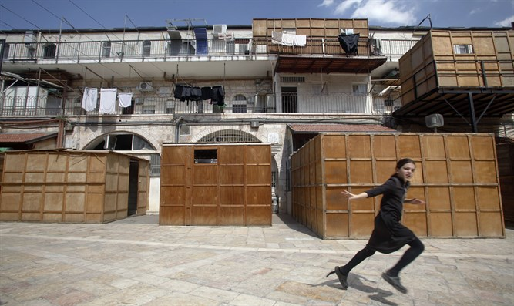

**Sukkahs Photo credit - Flash 90**

4. The Hebrew root of Sukkah stands for key characteristics of the relationship between the Jewish people, the Jewish Homeland and faith in G-d: Sukkah is “wholeness” and “totality”, the “shelter” of the tabernacle , “to anoint” , “divine curtain/shelter” and “attentiveness”.

5. The US covenant with the Jewish State is accentuated by Columbus Day, which is celebrated around Sukkot. According to "[C*olumbus Then and Now*](http://trailer.web-view.net/Links/0XF6931B9067A6DF13D6DEBC38B4D5A6EBC7D8FCF934EA6B2B7A94CC104A2BA83F79DC88774C9B015220744EB93A78D628384047ADCF9593ADE304CA8A6C04DAF7F865465AA68E69EA.htm)" (Miles Davidson, 1997, p. 268), Columbus arrived in America on Friday afternoon, October 12, 1492. It was the 21st day of the Jewish month of Tishrei, in the Jewish year 5235, on the 7th day of Sukkot, *Hoshaa'na' Rabbah*, which is a day of universal deliverance and miracles. Hosha' (הושע) is “deliverance” in Hebrew and Na’ (נא) is the Hebrew word for "please." The numerical value of Na’ in Hebrew is 51 (נ – 50, א – 1), which corresponds to the celebration of Hoshaa'na' Rabbah on the 51st day following Moses' ascension up to Mt. Sinai.

6. Sukkot, the Feast of Tabernacles (in Hebrew), is named after the first stop during the Exodus, the town of Sukkota (סכותה) - *Exodus* 13:20 and *Numbers* 33:3-5. It commemorates the transition of the Jewish people from bondage in Egypt to sovereignty in the Land of Israel; from nomadic life in the desert to permanence in the Promised Land; from oblivion to deliverance; and from the spiritual state-of-mind during the High Holidays to the mundane of the rest of the year. Sukkot aims at universal – not only Jewish – deliverance.

The Pilgrims, who knew their Bible, chose to celebrate Thanksgiving Day in the autumn as a symbol of the biblical holiday Sukkot, also aptly called the holiday of harvest.

7. Sukkot is the 3rd major Jewish holiday – following Rosh Hashanah and Yom Kippur - in the month of Tishrei, the holiest Jewish month. According to Judaism, 3 represents divine wisdom, stability, integration and peace. 3 is the total sum of the basic odd (1) and even (2) numbers. The 3rd day of the Creation was blessed twice ("And G-d observed that it was well done"); G-d appeared on Mt. Sinai 3 days following Moses’ ascension of the mountain; there are 3 parts to the Bible, 3 Patriarchs, 3 annual pilgrimages to Jerusalem, etc.

8. The commandment to erect Sukkot (booths), and celebrate a 7-day-holiday, is specified in *Leviticus* 23:42-43.

*Yoram Ettinger is a former ambassador and head of "Second Thought: a U.S.-Israel initiative." A writer, lecturer and consultant on US affairs, he is former Minister for Congressional Affairs and former Consul General in Houston, Texas*

*Reprinted from the October 4, 2017 email of Artuz Sheva.*